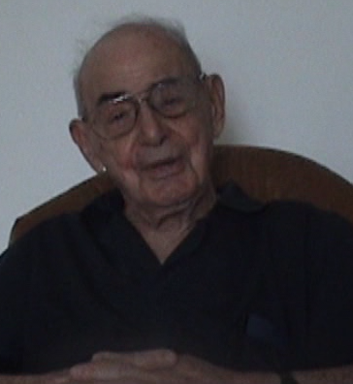
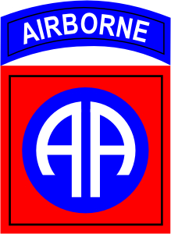
JOHN MARR
U.S AIRBORNE
&
WAR VETERAN

OUTBREAK OF THE WAR
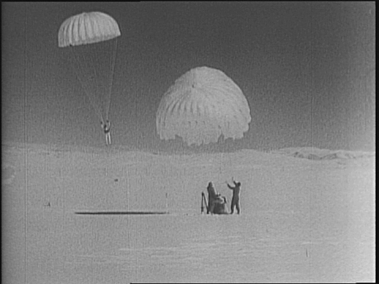
“When the war broke out it was June 1941, I was inducted in fort Levenworth Kansas then I was sent to Camp Roberts, California for basic training. While there I heard a call for people to train for the Airborne, having finished basic trianing in September of 1941 I was shipped to Fort Benning to become part of the 503rd parachute battalion. The unit I was in was sent to Utah to learn how to ski in order to ski down to communication centers held by Germans. We trained there for five weeks and after that we turned in the ski equiptment and we headed back to fort Benning. We became became the first parachute infantry, the 503^{rd,} and we were the first paratroopers to arrive at fort Brag.”

GRAY CASTLE
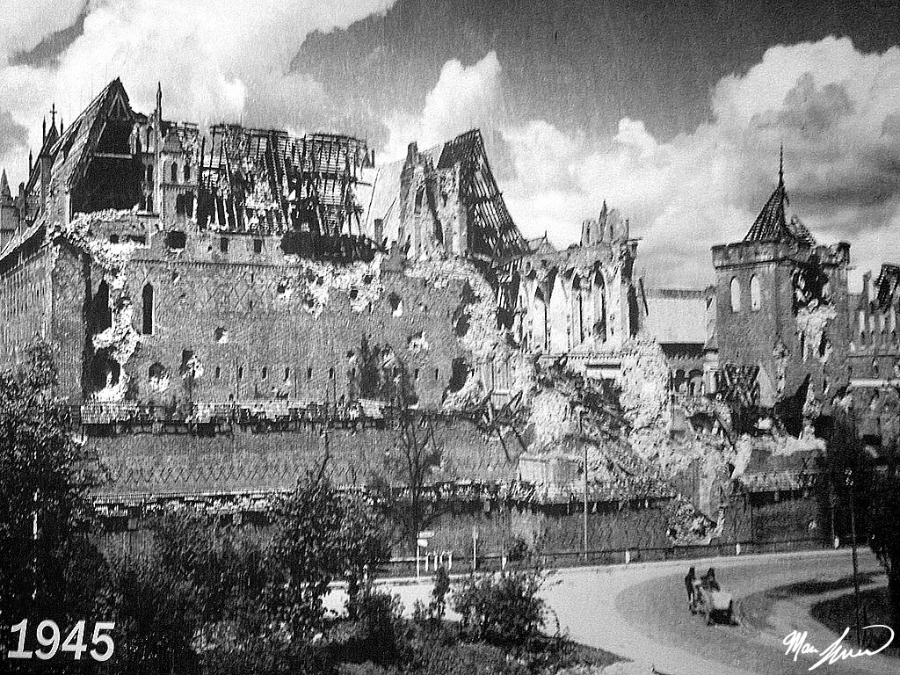
“I was told to take a patrol to a place called the Gray Castle later we found out the German 91st infantry was stationed at this castle. This was early in the morning I took a patrol of 7-8 people and went through the woods to attack the Gray Castle. We did not get very far until we were met with automatic fire. We retreated to the orchard and I mentioned that the castle would have to be taken at night. I said to the commanding officer that they would have an easier time getting close if I went with a runner to the castle. I was then given the blessing and I got a runner, Norman Carter. The Germans in the gray castle had decided to fire upon what they were hearing / detecting they were firing in the dark. C company of the 325 glider infantry elected to return fire and attack the gray castle.”

BATTLE OF THE BULGE
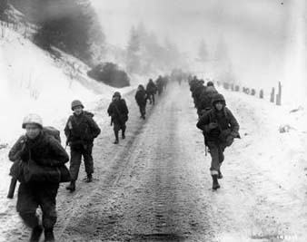
“While we were told we were going to be replaced in a week, no replacements were programed. The core commanders felt that we could not do without the divisions, they felt they needed the divisons to cut off the peninsula. We were there for about 5 weeks and my Company came out with 54 people out of 136 that is how a plan is made and disregarded. This battle showed the tenacity of the Airborne as well. The Germans attack was driven into Belgum and towards Antwerp. We was sent into the releave the situation at Bastogne the 507th regement and 17th airborne left the day before Christmas.”

COLD WAR
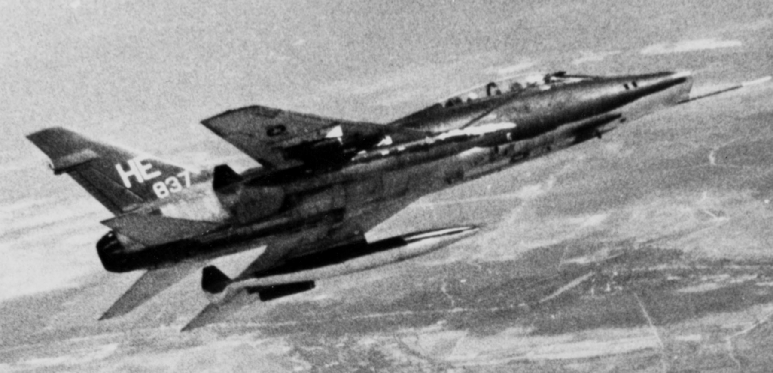
“I made the switch to pilot and I was reassigned to be a logistics officer and then sent back to the states. I was assigned to the airborne section of the infantry school, the air mobility group. I was asked if he wanted to take aviator training I said yes and I had gotten a notice that they were sending officers into flight training I got a card saying all the positions were filled. I then got a letter the army saying they will be hosting another program so I went back and told them I wanted to go then In 1959 I passed all the tests I started flight trianing in May 1960. I was made a section leader, I was going to command an aviation battalion the 8th division. I had to learn helecopters and went to texas for two months to learn. I came up on the list for Colonal however the army told him they did not need any. I was sent to Vietnam to command the 17th combat aviation group here I was assigned to operational control I was the commander of the group and the staff aviation officer in the force in Vietnam. I Spent a year here with the group it grew as the year passed and I came home from Vietnam in June of 1967.”

